# *Group 45 — Rick Bagiohan, Juan Antonio Go, Emmanuel Ocat, Rheymart Romero, Marlon Solon & Randy Velaco Date of submission: 12.23.2022* Group Workspace

## Tasks

*Here you should make a list of the most important tasks you set for week #1. Conduct a first team meeting and choose a framework.*

1. *Divide tasks among team members.*
2. *Briefing and requirements review*
3. *Distribute all tasks and plans among team members.*
4. *Develop a roadmap*
5. *Analyze the data*

## Strategic Roadmap

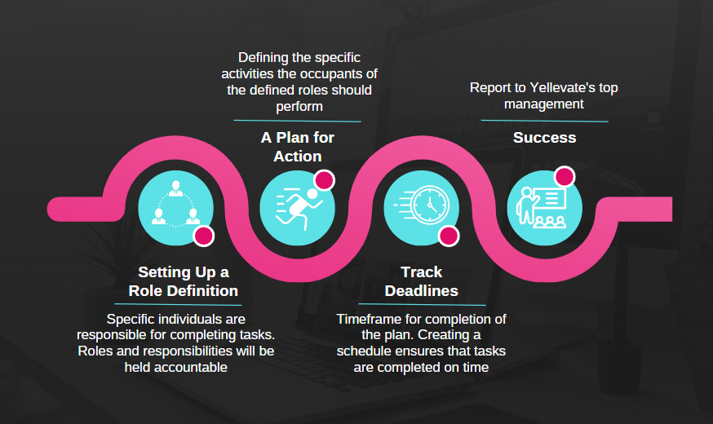

## Plan

Fill in the table below according to your tasks, their owners, deadline and status. Refer to the example in the table.

| **Task** | **Who is responsible** | **Deadline** | **Status** |
| --- | --- | --- | --- |
| Conduct a meeting and divide the tasks | Anton— Group Lead | 12.09.2022 | Completed |
| Create individual outputs | Everybody | 12.15.2022 | Completed |
| Present individual dashboard, insights & recommendations in Word & Excel format Part 1 | Everybody | 12.10.2022 | Completed |
| Present individual dashboard, insights & recommendations in Word & Excel format Part 2 | Everybody | 12.15.2022 | Completed |
| Decide final word,excel,sql output | Everybody | 12.15.2022 | Completed |
| Create & edit word, pdf, excel, content writing | Marlon | 12.15.2022 | Completed |
| Create powerpoint presentation | Marlon | 12.16.2022 | Completed |
| Assessing files based on criteria | Anton | 12.16.2022 | Completed |
| Edit files, create video recording | Marlon | 12.17.2022 | Completed |
| Submit all outputs on Thinkific. See GP1.13 | Everyone | 12.17.2022 | Completed |
|  |  |  |  |

## Notes

During your team meetings or chat discussions, you might think of some useful ideas that you don’t want to forget. Write them down here to return to them later. See an example below.

### Meeting #1

Date: 12.09.2022, 7-9pm

Who attended the meeting: All

What we discussed: Since everyone has done all/some of the outputs, we will share our individual outputs on the next meeting and decide what to include in the final output.

Next steps: Meeting on 12.10.2022 for individual presentation of outputs

### Meeting #2

Date: 12.10.2022,

Who attended the meeting: All  
What we discussed: Presented individual dashboard, insights & recommendations in Word & Excel format Part 1  
Recorded Zoom Meeting: ([click here](https://drive.google.com/drive/folders/1eMo8WTumfBrc-EJnXYUiQToNCjN1nbVB?usp=share_link))

Next steps: …Meeting on 12.15.2022 Presented individual dashboard, insights & recommendations in Word & Excel format Part 2  
  
**Meeting #3**

Date: 12.15.2022, 8:30-11:00

Who attended the meeting: All  
What we discussed: Presented individual dashboard, insights & recommendations in Word & Excel format Part 2, Decided the final output  
Recorded Zoom Meeting:

Next steps: …Meeting on 12.19.2022 Present final output (pdf,excel/sql,powerpoint/video presentation)

**Online Chat #4**

Date: 12.17.2022, 6:00PM-8:00PM

Who attended the meeting: All via discord  
What we discussed: Final output. We decided to send out the project in advance since the job was completed ahead of schedule.